How to Drain the DI Battery in an XPM2+/3/3i/3m.

- Power off the machine
- Open the front electrical cabinet and locate the DI module. This is the large black box to the right of the A1 circuit board.
- Loosen the two thumb screws that hold the DI module into the rack.
- Slide the DI board out of the cage and add a piece of paper between the battery and the tab on the top of it for 30 second as shown in the photo below. This will drain the controller.
- After 30 seconds remove the paper, slide the DI board back into the rack and tighten the thumb screws.
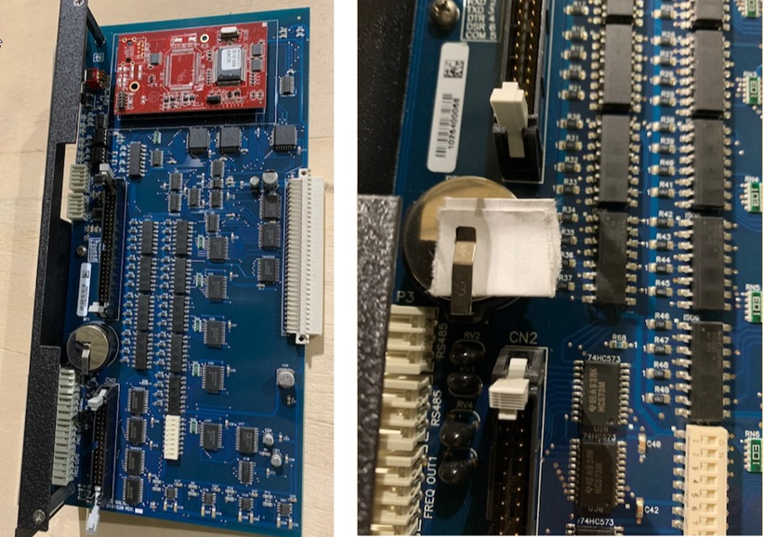

- Power on the machine. Once the software starts, make sure the machine is in stop mode and then click on Setup at the top of the screen and then "Configuration", and finally "Send to controller" as shown below. It will start the download. When it is done it will ask if you want to back up the machine configuration, choose No.

