Idle Mode

Idle mode is when a machine is running but not producing. In reflow process, this often goes with power consumption and nitrogen consumption that don’t contribute to throughput.

Centurion provides Idle Mode option to help you save power consumption and nitrogen to your specific requirements.

During Idle Mode, cell fan speed is lowered, conveyor speed is reduced, and nitrogen purge is lowered, all to the settings you entered to your production requirements. Time to go to Idle Mode can also be specified in the software.

As soon as SMEMA detects a board, the machine wakes up to the original recipe. Recovery time depends on recipe, Idle Mode setting, and location of SMEMA that can be specified by you. The machine can be awakened manually also.

A typic Idle Mode can save Power consumption up to 35%, and N2 consumption 40%. Examples are shown as below.

**Power Consumption Saving**

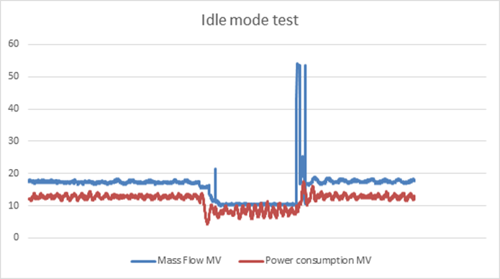

**Nitrogen Consumption Saving**

**Ready time**

|  |  |  |  |  |
| --- | --- | --- | --- | --- |
| **Set point (ppm)** | **Flow - idle (m3/h)** | **Flow – without idle(m3/h)** | **N2 saved (%)** | **Ready time(minutes)** |
| 5000 | 7.8 | 13.8 | 43.5 | 4 |
| 2000 | 7.8 | 17.2 | 54.7 | 6.8 |
| 2000 | 13.5 | 17.2 | 21.5 | 3.2 |
| 1000 | 7.8 | 19.8 | 60.6 | 8.2 |
| 1000 | 13.5 | 19.8 | 31.8 | 4.6 |
| 500 | 7.8 | 22 | 64.5 | 9.8 |
| 500 | 13.5 | 22 | 38.6 | 6.2 |
| 200 | 7.8 | 24 | 67.5 | 12 |
| 200 | 13.5 | 24 | 43.8 | 8.4 |