- Exit the Vitronics Software.
- Open Windows Explorer and Browse to the C:\Program Files\Vitronics\ folder. Make a copy of the data folder and paste the entire folder on the desktop. The key files that you will need a copy of are OvenConfiguration.mdb and A32config.mdb. These should be in the data\db folder on your desktop. Your recipes and product folders should also be in the data folder
- Start the Vitronics software and login as the System user.
- Open the Configure machine dialog by selecting menu item Setup->Configure Oven.
- Select the proper Machine type from the list and click the Apply button.

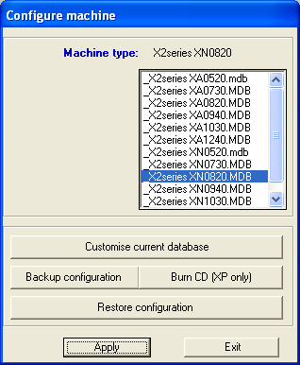

- A message stating that this will load Default Configuration settings... Click Yes to acknowledge.
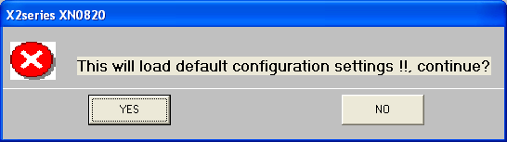
- Click the Exit button and click Yes when prompted to Restart Windows.
- Click OK when prompted that Windows will Restart...
- The Vitronics Program will shut down but Windows will not automatically Restart.
- Restart Windows.
- The Vitronics Software will start with default settings.
- Once it starts, Exit out of the Vitronics Software.
- Open the data/db folder on your desktop and copy the a32config.mdb file.
- Browse to the C:\Program Files\Vitronics\Data\db folder and paste the a32config.mdb file.
- Do the same thing for the OvenConfiguration.mdb file. Make sure to copy and paste both files and not drag and drop the files otherwise it will make them read only and you will have other issues.
- Start the Vitronics Software. The machine should be back to correct configuration and show the correct Series of machine at the top of the Vitronics Software

